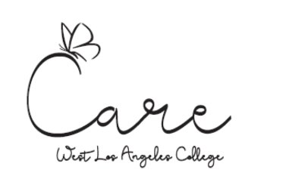

**CARE Program**

**Cooperative Agencies Resources for Education**

Thank you for your interest in the CARE Program.

**Step 1**

Complete an EOPS Program Application.

Once approved for the EOPS Program, you can apply for the CARE Program.

**Step 2**

Submit the following to apply for the CARE Program:

**Completed CARE application**

And

**Untaxed Income Verification -Agency Certification Form** - Completed by the Department of Social Services - CalWORKs Eligibility caseworker.

**Completed** CARE applications and supporting documents can be submitted at the EOPS/CARE/Next Up Office SSB 330 or email to wlac-care@laccd.edu

**Please email us if you have any questions at** wlac-care@laccd.edu